**Demonstrate Insertion, Updation, and Deletion of databases Records using JDBC**

**DBConnection.java**

import java.sql.Connection;

import java.sql.DriverManager;

import java.sql.PreparedStatement;

import java.sql.ResultSet;

import java.sql.SQLException;

public class DBConnection {

private static final String *URL* = "jdbc:mysql://localhost:3306/Products";

private static final String *USERNAME* = "root";

private static final String *PASSWORD* = "root";

public static Connection getConnection() throws SQLException {

return DriverManager.*getConnection*(*URL*, *USERNAME*, *PASSWORD*);

}

public static void close(Connection conn, PreparedStatement stmt, ResultSet rs) throws SQLException {

if (rs != null) rs.close();

if (stmt != null) stmt.close();

if (conn != null) conn.close();

}

}

**ProductDetails.java**

import java.io.IOException;

import java.io.PrintWriter;

import java.sql.Connection;

import java.sql.ResultSet;

import java.sql.SQLException;

import java.sql.Statement;

import javax.servlet.ServletException;

import javax.servlet.http.HttpServlet;

import javax.servlet.http.HttpServletRequest;

import javax.servlet.http.HttpServletResponse;

public class ProductDetails extends HttpServlet {

private static final long *serialVersionUID* = 1L;

protected void doGet(HttpServletRequest request, HttpServletResponse response) throws ServletException, IOException {

response.setContentType("text/html");

PrintWriter out = response.getWriter();

try {

Connection connection = DBConnection.*getConnection*();

Statement statement = connection.createStatement();

ResultSet resultSet = statement.executeQuery("SELECT * FROM product");

out.println("<html><head><title>Product Details</title></head><body>");

out.println("<h2>Product Details</h2>");

while (resultSet.next()) {

int id = resultSet.getInt(1);

String name = resultSet.getString(2);

String description = resultSet.getString(3);

double price = resultSet.getDouble(4);

out.println("<p>ID: " + id + "</p>");

out.println("<p>Name: " + name + "</p>");

out.println("<p>Description: " + description + "</p>");

out.println("<p>Price: " + price + "</p>");

out.println("<hr>");

}

out.println("</body></html>");

} catch (SQLException e) {

e.printStackTrace();

out.println("Error retrieving product details.");

}

}

protected void doPost(HttpServletRequest request, HttpServletResponse response) throws ServletException, IOException {

doGet(request, response);

}

}

**InsertProduct.java**

import java.io.IOException;

import java.io.PrintWriter;

import java.math.BigDecimal;

import java.sql.CallableStatement;

import java.sql.Connection;

import java.sql.DriverManager;

import java.sql.SQLException;

import javax.servlet.ServletException;

import javax.servlet.http.HttpServlet;

import javax.servlet.http.HttpServletRequest;

import javax.servlet.http.HttpServletResponse;

public class InsertProduct extends HttpServlet {

private static final long *serialVersionUID* = 1L;

protected void doPost(HttpServletRequest request, HttpServletResponse response) throws ServletException, IOException {

int id = Integer.*parseInt*(request.getParameter("id"));

String name = request.getParameter("name");

String description = request.getParameter("description");

BigDecimal price = new BigDecimal(request.getParameter("price"));

// Assuming you have a database connection setup

try

{

Connection con = DBConnection.*getConnection*();

CallableStatement stmt = con.prepareCall("call products.InsertProduct(?, ?, ?, ?)");

stmt.setInt(1, id);

stmt.setString(2, name);

stmt.setString(3, description);

stmt.setBigDecimal(4, price);

int rowsAffected = stmt.executeUpdate();

if (rowsAffected > 0) {

response.setContentType("text/html");

PrintWriter out = response.getWriter();

out.println("<h1>Data Inserted Successfully</h1>");

// Redirect or perform further actions if needed

} else {

response.setContentType("text/html");

PrintWriter out = response.getWriter();

out.println("<h1>Error while inserting data<h1>");

}

} catch (SQLException e) {

e.printStackTrace();

}

}

}

**DeleteServlet.java**

import java.io.IOException;

import java.io.PrintWriter;

import java.sql.Connection;

import java.sql.PreparedStatement;

import java.sql.SQLException;

import javax.servlet.ServletException;

import javax.servlet.http.HttpServlet;

import javax.servlet.http.HttpServletRequest;

import javax.servlet.http.HttpServletResponse;

/**

* Servlet implementation class DeleteServlet

*/

public class DeleteServlet extends HttpServlet {

private static final long *serialVersionUID* = 1L;

/**

* @see HttpServlet#HttpServlet()

*/

public DeleteServlet() {

super();

// TODO Auto-generated constructor stub

}

/**

* @see HttpServlet#doGet(HttpServletRequest request, HttpServletResponse response)

*/

protected void doGet(HttpServletRequest request, HttpServletResponse response) throws ServletException, IOException {

// TODO Auto-generated method stub

PrintWriter out=response.getWriter();

response.setContentType("text/html");

String paramater = request.getParameter("id");

int id= Integer.*parseInt*(paramater);

try {

Connection connection = DBConnection.*getConnection*();

PreparedStatement statement=connection.prepareStatement("delete from product where id=?");

statement.setInt(1, id);

int resultset = statement.executeUpdate();

if(resultset>0) {

response.setContentType("text/html");

out.print( "<h1>Deleted From Database</h1> ");

}

else {

System.*out*.println("Error while deleting a data");

}

//response.sendRedirect("ProductDetails");

} catch (SQLException e) {

// TODO Auto-generated catch block

e.printStackTrace();

}

}

/**

* @see HttpServlet#doPost(HttpServletRequest request, HttpServletResponse response)

*/

protected void doPost(HttpServletRequest request, HttpServletResponse response) throws ServletException, IOException {

// TODO Auto-generated method stub

doGet(request, response);

}

}

**UpdateServlet.java**

import java.io.IOException;

import java.io.PrintWriter;

import java.math.BigDecimal;

import java.sql.Connection;

import java.sql.PreparedStatement;

import java.sql.SQLException;

import javax.servlet.ServletException;

import javax.servlet.http.HttpServlet;

import javax.servlet.http.HttpServletRequest;

import javax.servlet.http.HttpServletResponse;

/**

* Servlet implementation class UpdateServlet

*/

public class UpdateServlet extends HttpServlet {

private static final long *serialVersionUID* = 1L;

/**

* @see HttpServlet#HttpServlet()

*/

public UpdateServlet() {

super();

// TODO Auto-generated constructor stub

}

/**

* @see HttpServlet#doGet(HttpServletRequest request, HttpServletResponse response)

*/

protected void doGet(HttpServletRequest request, HttpServletResponse response) throws ServletException, IOException {

// TODO Auto-generated method stub

PrintWriter out=response.getWriter();

response.setContentType("text/html");

String paramater=request.getParameter("id");

//converting string to int

int id= Integer.*parseInt*(paramater);

String name=request.getParameter("name");

String description = request.getParameter("description");

BigDecimal price=new BigDecimal(request.getParameter("price"));

try {

Connection con = DBConnection.*getConnection*();

PreparedStatement stmt = con.prepareStatement("UPDATE product SET name=?, description=?, price=? WHERE id=?");

stmt.setString(1, name);

stmt.setString(2, description);

stmt.setBigDecimal(3, price);

stmt.setInt(4, id);

int rowsAffected = stmt.executeUpdate();

if (rowsAffected > 0) {

response.getWriter().println("<h1>Record updated successfully.<h1.");

} else {

response.getWriter().println("<h1>Failed to update the record.</h1>");

}

con.close();

} catch (SQLException e) {

// TODO Auto-generated catch block

e.printStackTrace();

}

}

/**

* @see HttpServlet#doPost(HttpServletRequest request, HttpServletResponse response)

*/

protected void doPost(HttpServletRequest request, HttpServletResponse response) throws ServletException, IOException {

// TODO Auto-generated method stub

doGet(request, response);

}

}

**index.html**

<!DOCTYPE html>

<html>

<head>

<meta charset=*"ISO-8859-1"*>

<title>JDBC INDELUPDATE</title>

</head>

<body>

<!-- this one is for FETCH a RECORD -->

<H1>LIST OF PRODUCTS</H1>

<a href=*"ProductDetails"*>List Products</a>

<br>

<br>

<!-- this one is for CREATE a RECORD -->

<h1>Product Registration Form</h1>

<form action=*"InsertProduct"* method=*"post"*>

Product ID: <input type=*"text"* name=*"id"* placeholder=*"Enter Product ID"*><br><br>

Product Name: <input type=*"text"* name=*"name"* placeholder=*"Enter Product Name"*><br><br>

Product Description: <input type=*"text"* name=*"description"* placeholder=*"Enter Product Description"*><br><br>

Product Price: <input type=*"text"* name=*"price"* placeholder=*"Enter Product Price"*><br><br>

<input type=*"submit"* value=*"Add Prodcut"*>

</form>

<br>

<br>

<!-- this one is for DELETE a RECORD -->

<h1>DELETE RECORD</h1>

<form action=*"DeleteServlet"* method=*"post"*>

Product id: <input type=*"text"* name=*"id"* placeholder=*"Enter Product id"*><br><br>

<input type=*"submit"* value=*"DELETE Prodcut"*>

</form>

<br>

<br>

<!-- this one is for UPDATE a RECORD -->

<h1>UPDATE RECORD</h1>

<form action=*"UpdateServlet"* method=*"post"*>

Product ID: <input type=*"text"* name=*"id"* placeholder=*"Enter Product ID"*><br><br>

Product Name: <input type=*"text"* name=*"name"* placeholder=*"Enter Product Name"*><br><br>

Product Description: <input type=*"text"* name=*"description"* placeholder=*"Enter Product Description"*><br><br>

Product Price: <input type=*"text"* name=*"price"* placeholder=*"Enter Product Price"*><br><br>

<input type=*"submit"* value=*"UPDATE Prodcut"*>

</form>

</body>

</html>

**web.xml**

<?xml version=*"1.0"* encoding=*"UTF-8"*?>

<web-app xmlns:xsi=*"http://www.w3.org/2001/XMLSchema-instance"* xmlns=*"http://java.sun.com/xml/ns/javaee"* xsi:schemaLocation=*"http://java.sun.com/xml/ns/javaee http://java.sun.com/xml/ns/javaee/web-app_2_5.xsd"* id=*"WebApp_ID"* version=*"2.5"*>

<display-name>CRUDOperations</display-name>

<welcome-file-list>

<welcome-file>index.html</welcome-file>

<welcome-file>index.jsp</welcome-file>

<welcome-file>index.htm</welcome-file>

<welcome-file>default.html</welcome-file>

<welcome-file>default.jsp</welcome-file>

<welcome-file>default.htm</welcome-file>

</welcome-file-list>

<servlet>

<description></description>

<display-name>DeleteServlet</display-name>

<servlet-name>DeleteServlet</servlet-name>

<servlet-class>DeleteServlet</servlet-class>

</servlet>

<servlet-mapping>

<servlet-name>DeleteServlet</servlet-name>

<url-pattern>/DeleteServlet</url-pattern>

</servlet-mapping>

<servlet>

<description></description>

<display-name>ProductDetails</display-name>

<servlet-name>ProductDetails</servlet-name>

<servlet-class>ProductDetails</servlet-class>

</servlet>

<servlet-mapping>

<servlet-name>ProductDetails</servlet-name>

<url-pattern>/ProductDetails</url-pattern>

</servlet-mapping>

<servlet>

<description></description>

<display-name>InsertProduct</display-name>

<servlet-name>InsertProduct</servlet-name>

<servlet-class>InsertProduct</servlet-class>

</servlet>

<servlet-mapping>

<servlet-name>InsertProduct</servlet-name>

<url-pattern>/InsertProduct</url-pattern>

</servlet-mapping>

<servlet>

<description></description>

<display-name>UpdateServlet</display-name>

<servlet-name>UpdateServlet</servlet-name>

<servlet-class>UpdateServlet</servlet-class>

</servlet>

<servlet-mapping>

<servlet-name>UpdateServlet</servlet-name>

<url-pattern>/UpdateServlet</url-pattern>

</servlet-mapping>

</web-app>

**OUTPUT**

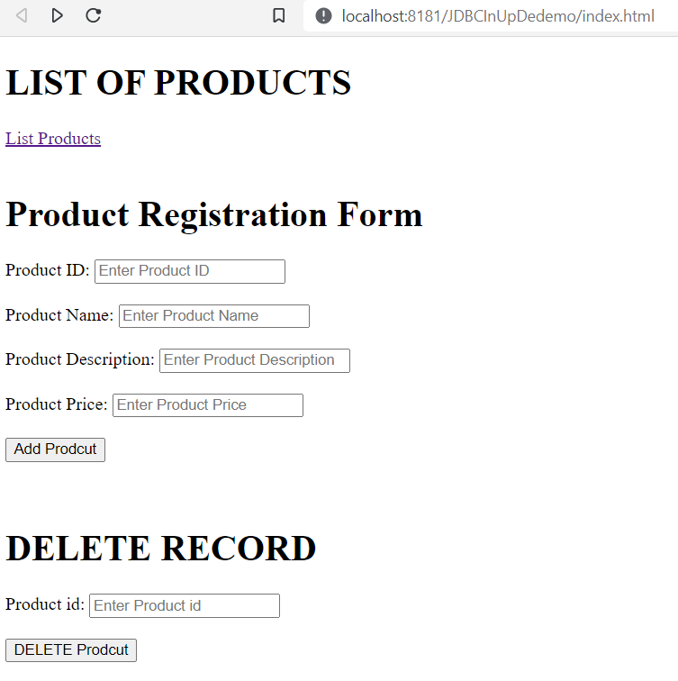

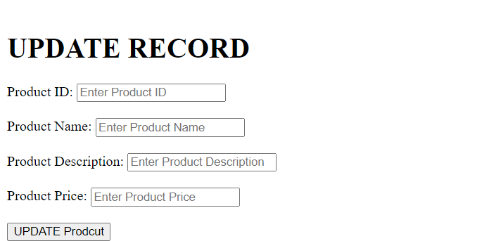

**Insert a record in Database**

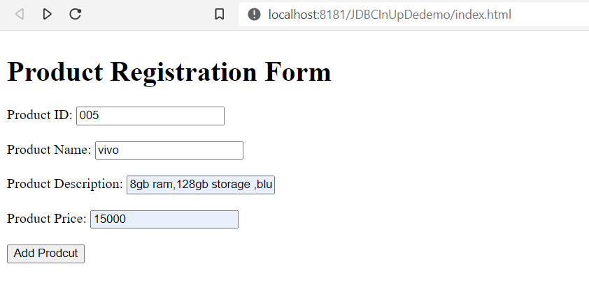

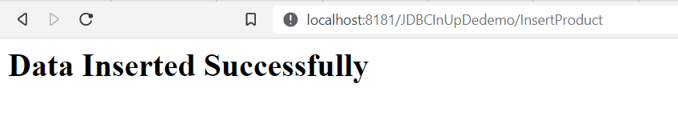

**Show Inserted Records in Database**

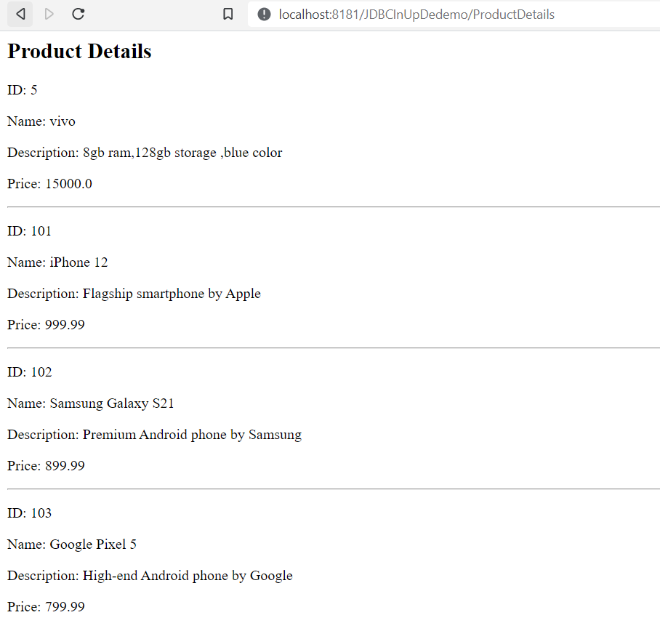

**Update a records in database**

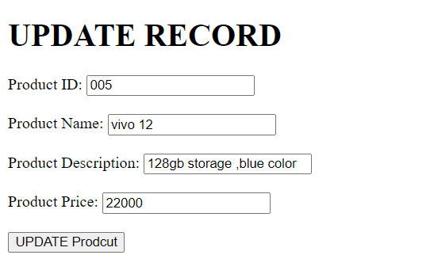

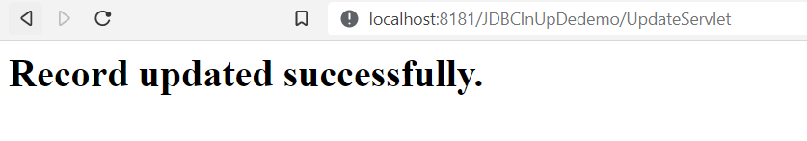

**Show updated records in Database**

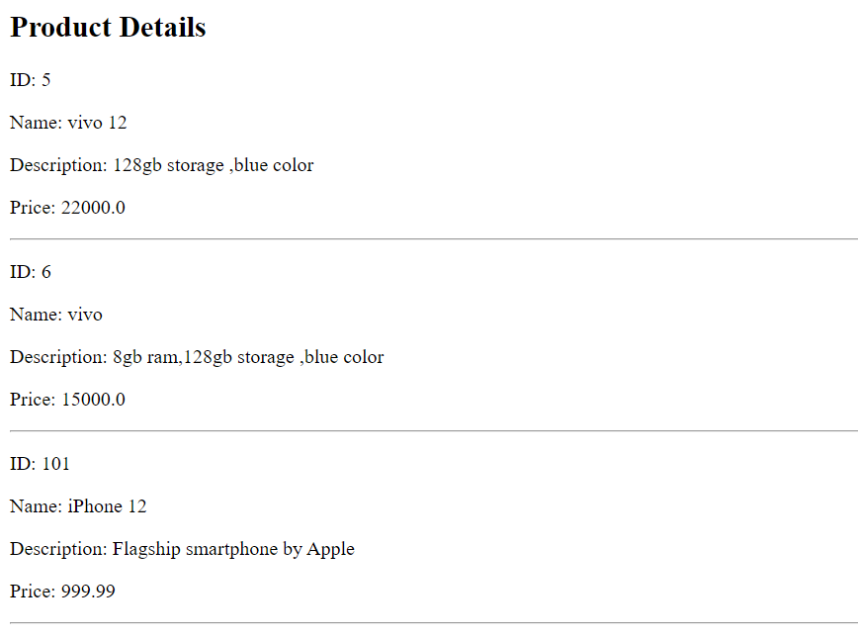

**Delete a Record in Database**

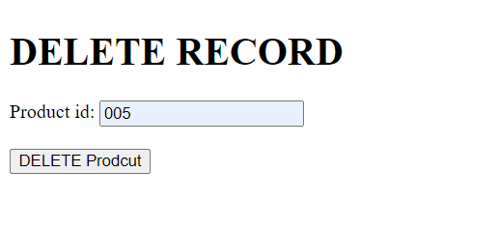

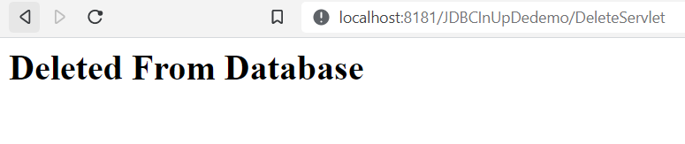

**Show the product details deleted records not shown in the list**

